1-Metaphor

🎭 What is a Metaphor?
# Source: AI Source: Provided by: [Data Path: Persons Table -> ID Column: 1, Name_En Column: Motasem Essam] -> From: [Chatgpt (GPT-4-turbo)] on [7/24/2025]
A metaphor is a figure of speech in which one thing is described as if it were something else, to create a vivid image or symbolic meaning — without using "like" or "as" (which are used in similes).

📘 Definition:
# Source: AI Source: Provided by: [Data Path: Persons Table -> ID Column: 1, Name_En Column: Motasem Essam] -> From: [Chatgpt (GPT-4-turbo)] on [7/24/2025]
A metaphor is a way of comparing two unrelated things by saying one is the other, to suggest they share similar qualities.

🔍 Example Metaphors:
# Source: AI Source: Provided by: [Data Path: Persons Table -> ID Column: 1, Name_En Column: Motasem Essam] -> From: [Chatgpt (GPT-4-turbo)] on [7/24/2025]
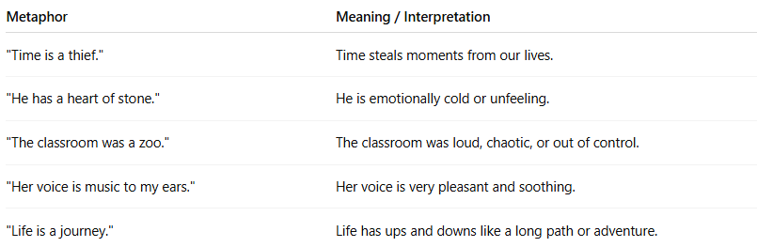
Metaphor | Meaning / Interpretation
"Time is a thief." | Time steals moments from our lives.
"He has a heart of stone." | He is emotionally cold or unfeeling.
"The classroom was a zoo." | The classroom was loud, chaotic, or out of control.
"Her voice is music to my ears." | Her voice is very pleasant and soothing.
"Life is a journey." | Life has ups and downs like a long path or adventure.

✅ Characteristics of Metaphors:
# Source: AI Source: Provided by: [Data Path: Persons Table -> ID Column: 1, Name_En Column: Motasem Essam] -> From: [Chatgpt (GPT-4-turbo)] on [7/24/2025]
- No "like" or "as" (that’s a simile).
- Often used in poetry, literature, and everyday speech.
- Creates emotional impact or visual imagery.
- Can be simple or extended (used throughout a sentence or paragraph).

🎨 Metaphor vs Simile:
# Source: AI Source: Provided by: [Data Path: Persons Table -> ID Column: 1, Name_En Column: Motasem Essam] -> From: [Chatgpt (GPT-4-turbo)] on [7/24/2025]
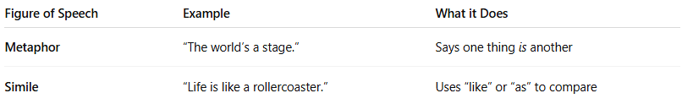
Figure of Speech | Example | What it Does
Metaphor | “The world’s a stage.” | Says one thing is another
Simile | “Life is like a rollercoaster.” | Uses “like” or “as” to compare

✅ Summary:
# Source: AI Source: Provided by: [Data Path: Persons Table -> ID Column: 1, Name_En Column: Motasem Essam] -> From: [Chatgpt (GPT-4-turbo)] on [7/24/2025]
A metaphor is a powerful way to express ideas by saying something is something else, helping create a strong image, feeling, or idea.

2-Simile

✨ What is a Simile?
# Source: AI Source: Provided by: [Data Path: Persons Table -> ID Column: 1, Name_En Column: Motasem Essam] -> From: [Chatgpt (GPT-4-turbo)] on [7/24/2025]
A simile is a figure of speech that compares two different things using the words “like” or “as”. It highlights a shared quality or characteristic between them, helping to create a vivid image or make an idea easier to understand.

📘 Definition:
# Source: AI Source: Provided by: [Data Path: Persons Table -> ID Column: 1, Name_En Column: Motasem Essam] -> From: [Chatgpt (GPT-4-turbo)] on [7/24/2025]
A simile is a comparison between two unlike things using “like” or “as” to suggest they are similar in some way.

🔍 Examples of Similes:
# Source: AI Source: Provided by: [Data Path: Persons Table -> ID Column: 1, Name_En Column: Motasem Essam] -> From: [Chatgpt (GPT-4-turbo)] on [7/24/2025]
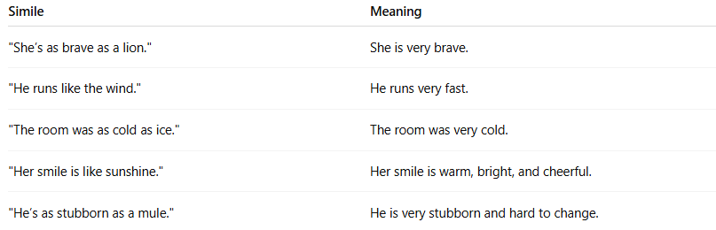

Simile | Meaning
"She’s as brave as a lion." | She is very brave.
"He runs like the wind." | He runs very fast.
"The room was as cold as ice." | The room was very cold.
"Her smile is like sunshine." | Her smile is warm, bright, and cheerful.
"He’s as stubborn as a mule." | He is very stubborn and hard to change.

✅ Key Features of Similes:
# Source: AI Source: Provided by: [Data Path: Persons Table -> ID Column: 1, Name_En Column: Motasem Essam] -> From: [Chatgpt (GPT-4-turbo)] on [7/24/2025]
- Always use “like” or “as”
- Used to compare two different things
- Helps create a clear image or emotion
- Common in poetry, storytelling, and everyday speech

🎭 Simile vs. Metaphor:
# Source: AI Source: Provided by: [Data Path: Persons Table -> ID Column: 1, Name_En Column: Motasem Essam] -> From: [Chatgpt (GPT-4-turbo)] on [7/24/2025]
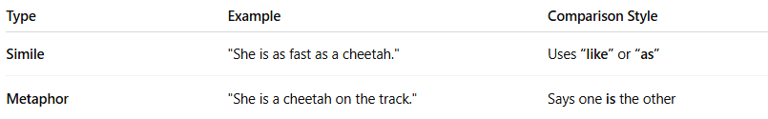

Type | Example | Comparison Style
Simile | "She is as fast as a cheetah." | Uses “like” or “as”
Metaphor | "She is a cheetah on the track." | Says one is the other

✅ Summary:
# Source: AI Source: Provided by: [Data Path: Persons Table -> ID Column: 1, Name_En Column: Motasem Essam] -> From: [Chatgpt (GPT-4-turbo)] on [7/24/2025]
A simile compares two different things using “like” or “as” to highlight a similarity.
It makes language more descriptive, imaginative, and expressive.

3-Metonymy

🧠 What is Metonymy?
# Source: AI Source: Provided by: [Data Path: Persons Table -> ID Column: 1, Name_En Column: Motasem Essam] -> From: [Chatgpt (GPT-4-turbo)] on [7/24/2025]
Metonymy is a figure of speech where you refer to something indirectly by naming something closely associated with it, rather than the thing itself.

📘 Definition:
# Source: AI Source: Provided by: [Data Path: Persons Table -> ID Column: 1, Name_En Column: Motasem Essam] -> From: [Chatgpt (GPT-4-turbo)] on [7/24/2025]
Metonymy is a linguistic device in which a word or phrase is replaced with another that is closely related in meaning or context, not a literal part of it.

🔍 Common Examples of Metonymy:
# Source: AI Source: Provided by: [Data Path: Persons Table -> ID Column: 1, Name_En Column: Motasem Essam] -> From: [Chatgpt (GPT-4-turbo)] on [7/24/2025]
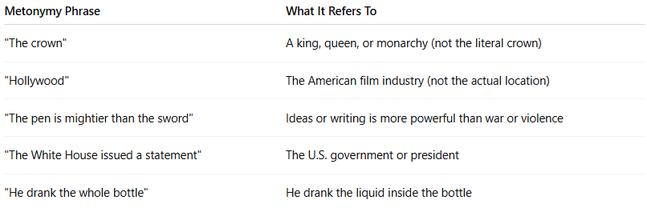

Metonymy Phrase | What It Refers To
"The crown" | A king, queen, or monarchy (not the literal crown)
"Hollywood" | The American film industry (not the actual location)
"The pen is mightier than the sword" | Ideas or writing is more powerful than war or violence
"The White House issued a statement" | The U.S. government or president
"He drank the whole bottle" | He drank the liquid inside the bottle

🧬 Difference Between Metonymy and Metaphor:
# Source: AI Source: Provided by: [Data Path: Persons Table -> ID Column: 1, Name_En Column: Motasem Essam] -> From: [Chatgpt (GPT-4-turbo)] on [7/24/2025]
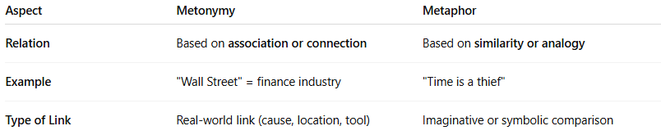

Aspect | Metonymy | Metaphor
Relation | Based on association or connection | Based on similarity or analogy
Example | "Wall Street" = finance industry | "Time is a thief"
Type of Link | Real-world link (cause, location, tool) | Imaginative or symbolic comparison

Metonymy vs Simile vs Metaphor

🔍 1. Metonymy
# Source: AI Source: Provided by: [Data Path: Persons Table -> ID Column: 1, Name_En Column: Motasem Essam] -> From: [Chatgpt (GPT-4-turbo)] on [7/24/2025]
Definition:
A figure of speech where something is referred to by the name of something closely associated with it, rather than by its own name.
Examples:
- "The pen is mightier than the sword."
→ Pen = writing; sword = warfare
- "The White House issued a statement."
→ White House = the U.S. President or government
Key Feature:
Based on association, not resemblance. It's literal proximity or symbolic link, not a comparison.

🔍 2. Simile
# Source: AI Source: Provided by: [Data Path: Persons Table -> ID Column: 1, Name_En Column: Motasem Essam] -> From: [Chatgpt (GPT-4-turbo)] on [7/24/2025]
Definition:
A figure of speech that compares two different things using "like" or "as" to highlight similarities.
Examples:
- "She is as brave as a lion."
- "He runs like the wind."
Key Feature:
Direct comparison using "like" or "as".

🔍 3. Metaphor
# Source: AI Source: Provided by: [Data Path: Persons Table -> ID Column: 1, Name_En Column: Motasem Essam] -> From: [Chatgpt (GPT-4-turbo)] on [7/24/2025]
Definition:
A figure of speech that states one thing is another, implying a symbolic or figurative resemblance.
Examples:
- "Time is a thief."
- "He has a heart of stone."
Key Feature:
Implied comparison without "like" or "as"; it's figurative substitution.

📊 Comparison Table
# Source: AI Source: Provided by: [Data Path: Persons Table -> ID Column: 1, Name_En Column: Motasem Essam] -> From: [Chatgpt (GPT-4-turbo)] on [7/24/2025]
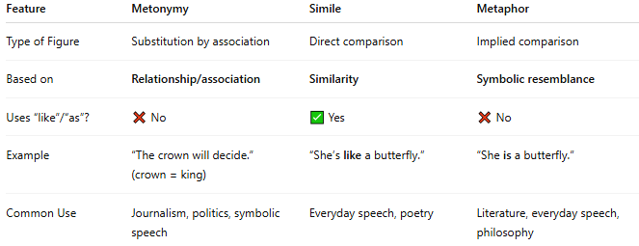
Feature | Metonymy | Simile | Metaphor
Type of Figure | Substitution by association | Direct comparison | Implied comparison
Based on | Relationship/association | Similarity | Symbolic resemblance
Uses “like”/“as”? | ❌ No | ✅ Yes | ❌ No
Example | “The crown will decide.” (crown = king) | “She’s like a butterfly.” | “She is a butterfly.”
Common Use | Journalism, politics, symbolic speech | Everyday speech, poetry | Literature, everyday speech, philosophy

✅ Summary:
# Source: AI Source: Provided by: [Data Path: Persons Table -> ID Column: 1, Name_En Column: Motasem Essam] -> From: [Chatgpt (GPT-4-turbo)] on [7/24/2025]
Metonymy is when you refer to something by naming something closely connected to it — like saying "the crown" to mean "the king".
It's a powerful tool in both language and literature, helping make speech more concise and vivid.

